Globalization Project Overview

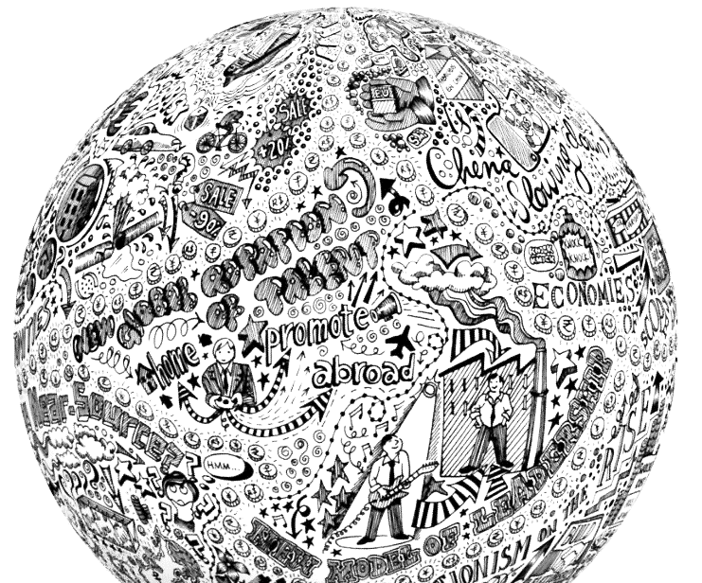
It has been said that arguing against globalization is like arguing against the laws of gravity.
- Kofi Annan

Context and Relevance
Globalization is all around us. We buy products from other countries, compete with students and workers halfway across the world, use technology to connect to different communities and cultures, travel around the globe, give to international aid campaigns, are threatened by transnational terrorism and disease epidemics, and share a single planet earth with some 7 billion other inhabitants.
In the past 30 years these changes have helped cut the global poverty rate has been cut in half—a remarkable feat of progress due. Still, globalization does not benefit everyone equally; it may create winners and losers, widening the gap between rich and poor, and irreparably changing our cultural and ecological resources.
In this project, we will be examining these economic, political and socio-cultural forces in our lives, and on a global scale. We’ll explore the ways we are complicit in globalization, and the choices we can make.

Project Overview
For this project, we will each be researching a particular aspect of globalization, developing an opinion, and expressing that opinion in an opinion editorial (op-ed) and a political cartoon. We will submit our opinion editorials to media outlets for potential publication and public exhibition.
Part 1: Research
In this part of the project, you will choose an aspect of globalization that interests you. (With some guidance from Ally. A list of topics is forthcoming.) Next, you will find multiple sources with differing perspectives to educate yourself about the issue, and to help you develop your own opinion. During this process, you will be asked to complete detailed research notes that should make the process of writing your opinion editorial more efficient.
Part 2: Opinion Editorial Writing
In the second part of the project, you will be crafting and refining a 750 to 1000-word piece of writing that urges your readers to take some action.
Part 3: Political Cartoon
Finally, learn to create political cartoons. Your cartoon will express the same perspective you develop in your opinion editorial, only in visual form. We will learn about different cartooning techniques, how to create a polished cartoon if your drawing skills are on par with a drunken monkey, and how to use text effectively in a cartoon.

Challenge Extensions
You have two options for a challenge extension in this project. If you are REALLY ambitious, you could combine these two options for super-ultra-mega-challenge!
Option 1: Extended Metaphor
For this challenge extension, you will build your opinion editorial and political cartoon around an extended metaphor. An extended metaphor is complex and deep enough to use to explore multiple aspects of your topic. In a cartoon, the extended metaphor will be shown through symbols and visual representations. This is a good choice for students who like to think a bit more creatively!
Option 2: Difficult Topics
Some aspects of globalization are particularly complex, and the research required to write an effective opinion editorial will be a bit more difficult, in terms of the reading level, concepts and workload. This is a good choice for students who want to use their intellects to dig deeply.
Option 3: Your Suggestion
As always, I am open to suggestions for other challenge extensions. If you think of something, please come and talk to me, or send me an email. Chances are good that I will approve your idea!

