The Intelligence Squared Project Overview
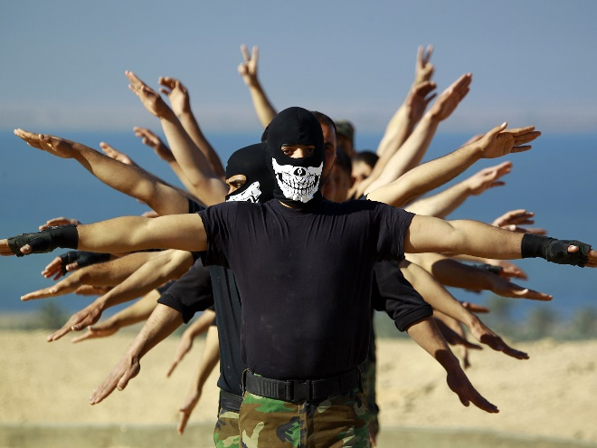
“The values that we are fighting against ISIS for are precisely that we don’t discriminate against people based on their faith.”
– Barak Obama

“I would bomb the s— out of 'em. I would just bomb those suckers.”
– Donald Trump
“Everyone’s worried about stopping terrorism. Well, there’s really an easy way: Stop participating in it.”
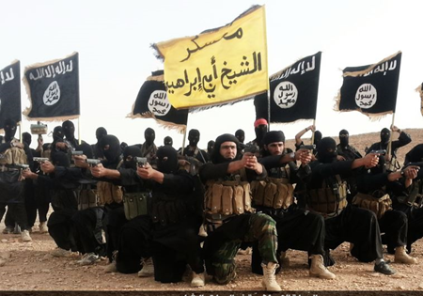
– Noam Chomsky
Essential Questions
- What forces created ISIS?
- How should the US respond to ISIS?
- How should the US balance security and human rights?

Context and Relevance
Discussions of the Islamic State of Iraq and Syria (ISIS) dominate the news and presidential debates. We are horrified by reports of beheadings, crucifixions, sex slavery and the destruction of antiquities. We are frightened by terrorist attacks, from September 11th and the San Bernardino shootings, to Charlie Hebdo and the November 2015 Paris attacks.
But how much do we really know about the origins, aims, and threats posed by ISIS? Given what we know about ISIS, how should we respond to them? Does intervention do more to help or harm?

Project Overview
In this project we’ll dig beneath the political rhetoric and easy explanations to a nuanced understanding.
We’ll be learning about the geopolitical, ideological and rhetorical origins of ISIS. Then, we’ll explore some of the policy options that the United States could pursue. Students will write a position paper on a policy that interests them. Finally, teams of students will debate the merits of those policies in Intelligence Squared-style debates (IQ2). A live audience will vote to determine the debate winners at all-school exhibition.

