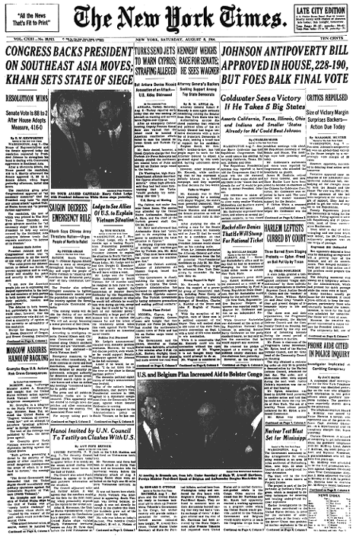

Congress Backs President on Southeast Asia Moves; Khanh Sets State of Siege
Resolution Wins

Senate Vote Is 88 to 2 After House Adopts Measure, 416-0

By E. W. Kenworthy

Special to THE NEW YORK TIMES
Washington, Aug. 7 -- The House of Representatives and the Senate approved today the resolution requested by President Johnson to strengthen his hand in dealing with Communist aggression in Southeast Asia.
After a 40-minute debate, the House passed the resolution; 416 to 0. Shortly afterward the Senate approved it, 88 to 2. Senate debate, which began yesterday afternoon, lasted nine hours.
The resolution gives prior Congressional approval of "all necessary measures" that the President may take "to repel any armed attack" against United States forces and "to prevent further aggression."
The resolution, the text of which was printed in The New York Times Thursday, also gives advance sanction for "all necessary steps: taken by the President to help any nation covered by the Southeast Asia collective defense treaty that requests assistance "in defense of its freedom."
Johonson Hails Action
President Johnson said the Congressional action was "a demonstration to all the world of the unity of all Americans."
"The votes prove our determination to defend our forces, to prevent aggression and to work firmly and steadily for peace and securityin the area," he said.
"I am sure the American people join me in expressing the deepest appreciation to the leaders and members of both parties in both houses of Congress for their patriotic, resolute and rapid action."
The debates in both houses, but particularly in the Senate, made clear, however, that the near-unanimous vote did not reflect a unanimity of opinion on the necessity or advisability of the resolution.
Except for Senators Wayne L. Morse, Democrat of Oregon, and Ernest Gruening, Democrat of Alaska, who cast the votes against the resolution, members in both houses uniformly praised the President for the retaliatory action he had ordered against North Vietnamese torpedo boats and their bases after the second torpedo boat attack on United States destroyers in the Gulf of Tonkin.
Expansion Held Inevitable
Representative of these doubts and reservations were the brief remarks by Senator George D. Aiken, Republican of Vermont. Senator Aiken, a member of the Foreign Relations Committee, said:
"It has been apparent to me for some months that the expansion of the war in Southeast Asia was inevitable. I felt that it shouldn't occur, but the discussion wasn't mine.
"I am still apprehensive of the outcome of the President's decision, but he felt that the interests of the United States required prompt action. As a citizen I feel I must support our President whether his discussion is right or wrong.
"I hope the present action will prove to be correct. I support the resolution with misgivings."

