Truth of War Art Project
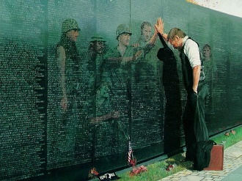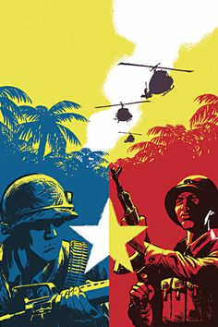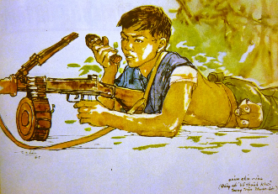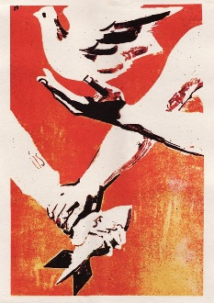

For the final piece of our “Truth of War” Project, your task is to create a piece of art that expresses one “truth” about war. You may create any type of art: visual, performance, audio, written.

Through our art, we’ll be exploring the essential questions:
- What truths can art express about war?
- What makes art impactful?
- Can art actually change anything?

Art pieces could include, but are not limited to:

- Paining/Drawing
- Collage/Mixed Media
- Photography
- Street Art
- Sculpture/Installation
- Video/Animation
- Podcast
- Spoken Word
- Music
- Dance
- One Act Play
- Poetry
- Short Story
- Curated Collection
- Infographic

We will exhibit our projects at an artists’ reception a class on Friday, January 15th.
Monday | Tuesday | Wednesday | Thursday | Friday
4th | 5th  Project Proposals  Due | 6th | 7th  Field Trip  to FLC | 8th
11th  Geometry  Field Trip | 12th  Gallery Walk  Art Critique | 13th  Statement  Critiques | 14th | 15th  Artist’s Reception  Statement Due
17th  No School | 18th  DP Updates Due

Checkpoint | Due Date | Points Possible | Stamp
Project Proposal | January 5th | 5
Gallery Walk  Art Critique | January 12th | 5 (No late work or extensions.)
Statement Critique | January 14th | 5 (No late work or extensions.)
DP Update | January 18th | 5
Name: ______________________
Section: _____________________

There are five checkpoints,
worth 5 points each.

The final project is worth 40 points: 30 points for the art piece.
10 points for the artists’ statement.

Art Piece Rubric
 | Did you exhibit a piece of original, creative work at our class exhibition?  Does your art piece communicate a truth or theme about war?  Is your art piece carefully crafted, with no signs of sloppy work?  Does your art piece reflect refinement throughout the project?  Is your art piece unique and personal?  Are you genuinely proud of your art piece?  _________________________________________________________________________  _________________________________________________________________________ | C  B  A

Artists’ Statement Rubric
 | Is your statement neatly printed, with a title, name and date?  Is your statement a single, indented paragraph?  Are your sentences complete and grammatically correct?  Have you thoroughly proofread your statement?  Are your sentences clear and easy to follow?  Does your statement have a clear topic sentence about the truth of war you are communicating?  Do you refer to elements of your work as evidence?  Does your analysis explain your how you made those creative choices?  Do you use sophisticated vocabulary, varied sentence structures and descriptive language?  Does your statement go beyond a basic summary to deep reflection and sophisticated discussion? | C  B  A

I will subtract one-half grade for every proofreading error (spelling, capitalization, punctuation, etc.)

