Heading Instructions
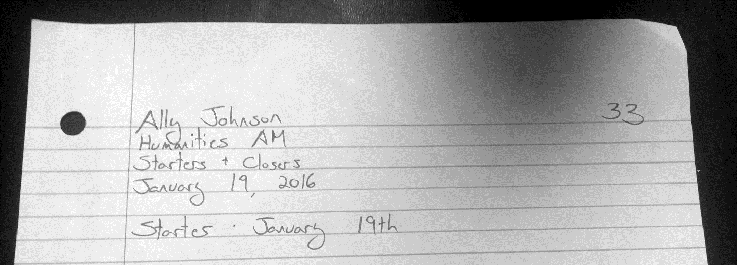
I will not give you credit for your work unless the heading looks like this. SRSLY. MLA format 4LYFE, whether your work is digital or hard copy.
- Full name on the left on the first line.
- Your number on the right on the first line.
- One piece of information per line.
- The section title below the heading.
- One inch margins without writing.

Comparison Instructions - The Lexus and the Olive Tree
- Underline the eight of the defining characteristics of the Cold War era listed in paragraph seven.
- Underline the eight places where he talks about the same thing for globalization.
(Hint: They are not in the same order and you can compare ideas to culture, as there isn’t a 1:1 comparison).
- On a note-taking page, create a T-chart with space for each characteristic.
- Come see Ally to get a topic to dive into and a partner to work with.
- Together, come up with a three-minute mini-lesson to teach the class including:
  - A representation of the comparison, such as a short skit, a sketch of a symbol, a silly song, a frieze scene, etc.
  - An explanation of what the shift was, and why it matters.
  - Readiness to answer your classmates' (basic) questions about your topic.
- Use your classmates' mini-lessons to take notes on each topic on your T-Chart.
- File your T-Chart in the notes section of your binder.
Discussion Instructions - The Lexus and The Olive Tree
The goal of this discussion is to help everyone understand and engage with the article deeply, just like in a seminar. The expectations are:
- Everyone Participates
- Use the entire time.
- Reference the text.

Questions:
- How would you define globalization, using evidence from The Lexus and the Olive Tree?
- What is Friedman’s opinion of globalization, based on what you’ve read in this article? What clues about his opinion do you see in the text?
- What are the pros and cons of globalization, as you see them so far?
- Of the 8 comparisons he makes between the cold war and globalization, which of the 8 do you think is MOST important? Why?
- Of the 8 comparisons he makes between the cold war and globalization, which of the 8 do you think is LEAST important? Why?
- How do you see what Friedman describes in your own life? How accurate do you think his description of globalization is?
- Which world would you rather live in, the Cold War system, or the globalized one? Why?
- Do you think you, as an individual, are more or less powerful in a globalized system? Why?
- What implications does globalization have for democracy, if elected governments are no longer the most powerful forces in the world, as Friedman argues in the middle of page eight?

Reflection Journal Instructions
- Begin a new document with a heading and your number at the top.
- If the document is digital, share it with Ally.
- Title the first section “The Lexus and the Olive Tree.”
- Take one to three paragraphs to reflect on what you read and discussed.
This is a space to express your thoughts and feelings about Friedman’s ideas.
I’m looking for your opinion, rather than a right or wrong answer.
- If the document is paper, file it in the “classwork” section of your binder.
- We will be journaling on a different topic each day, and turning in our thoughts on Friday.

